FTTH Fiber Terminal Box

Quick Details of FTTH Fiber Terminal Box:
Place of Origin: Shenzhen, China (Mainland);
Brand Name: OPTICO;
Product name: Fiber Terminal Box;
Application: FTTH FTTB FTTX Network;
Type: FDB;
Certification: CE, RoHS, ISO, CPR;
Color: White;
Fiber Type: G657A2;
Material: ABS/ PC;
Price Terms: FOB 7~15 USD/pcs;
Payment Terms: T/T, West Union, L/C; 30% deposit, 70% balance before shipment;
CABLE ports: 4-48;
weight: 0.35kg-5kg;

Fiber optic terminal box is suitable for the distribution and terminal connection for various kinds of optical fiber system, especially suitable for mini-network terminal distribution, in which the optical cables, patch cores or pigtails are connected.

Features of FTTH Fiber Terminal Box:
The box is made of PC/ABS, and lifetime is more than 20 years.
It also can be used under -40°C~80°C.
Bi-layer structure design. The upper layer is for optical splitter, the other layer is for fiber splicing.
Easy to operate. Usually installed as wall mounted in the building or at the green belt.
It can accommodate 8 pcs SC-SC, or SC-FC adapters.
It can be designed to client requirements.
It meets YD/T988-2007 standards.

Application of FTTH Fiber Terminal Box:
FTTH access network
Telecommunication Networks
CATV Networks
Data communications Networks

Type | FDB-04 | FDB-08 | FDB-16 | FDB-24 | FDB-32 | FDB-48
Size(mm) | 210*140*40 | 205*215*55 | 260*320*90 | 295*335*115 | 350*340*120 | 350*340*120
Cable ports | 4 | 8 | 16 | 24 | 32 | 48
Weight(kg) | 0.35 | 0.75 | 1.4 | 2.1 | 3.5 | 5

FAQ of FTTH Fiber Terminal Box:
- Why choosing OPTICO to be one of your partner?
(1).Professional manufacturer: Low MOQ, free samples are available.
(2).Quality assurance:Stable high quality.
(3).Customers solutions:Quick.
(4).Win-Win Price:Save much costs, bring more benefits for customers.

2. Do you accept OEM, such as: print our LOGO?
Yes, OEM order is welcome, Customized Logo is available.

3.What's the method of shipment?
The goods will be sent by International express, such as DHL/Fedex. It takes 3~7 days.
By train(parts of Europe area), or by sea.

Company Certificates:
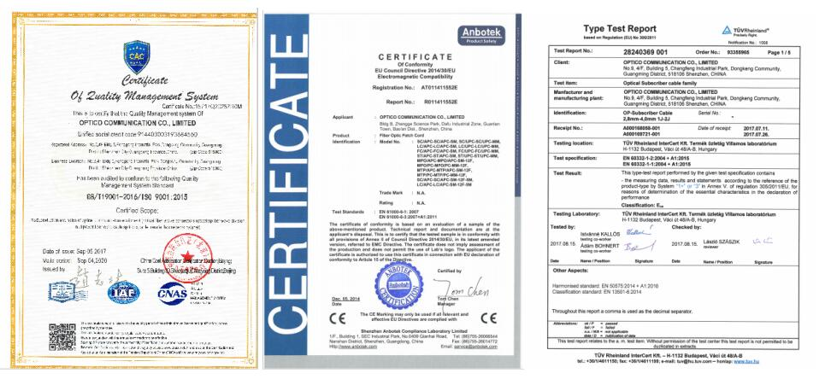

Optico Company Strength:
Shenzhen Optico Communication Co., Ltd is one of the leading manufacturers for fiber optic components in China, with an experience in this field for more than 18 years. We produce and wholesale fiber pigtail, patch cord, PLC Splitter, splice closure, terminal box, distribution box, WDM, etc, and various fiber networks connection solutions. Due to our good quality and best service, our products are successfully exported to more than 30 countries in the world. OPTICO is our brand.
Look forward to establish long-term business partnership with you. And make our max effort together on the fiber communication field.

